1. Release the 6 leg locks (J) and fully extend the tripod legs
2. Raise the central column (C) by first loosening the central column lock knob (D). Slide the central column up until the “Stop” marker appears. Then tighten the central column lock knob

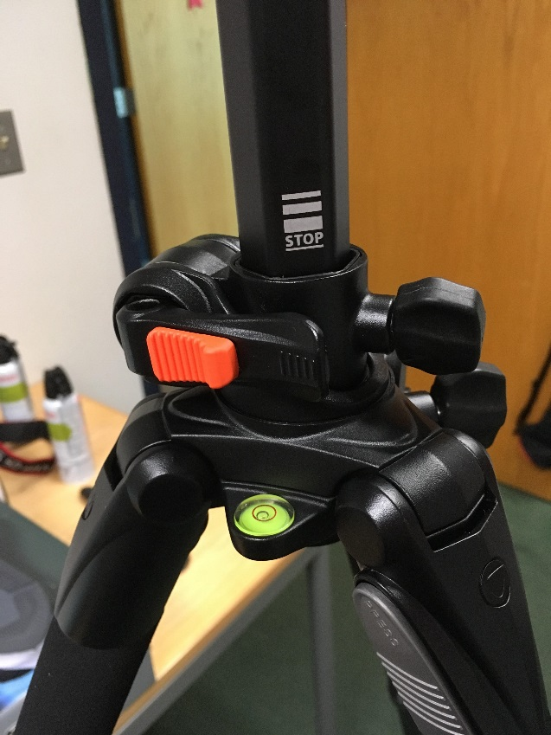

1. Slide the orange lever on the Instant Swivel Stop-n-Lock (M) to the right, then pull back the Instant Swivel Stop-n-Lock

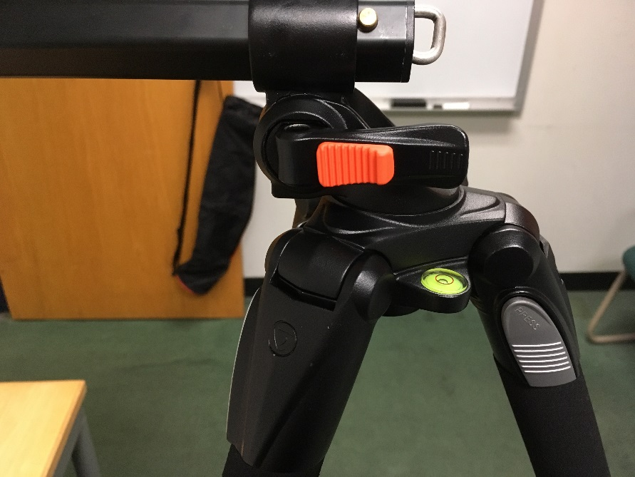

1. You should now be able to adjust the central column. Move it downward 90 degrees. The central column should now be parallel to the ground

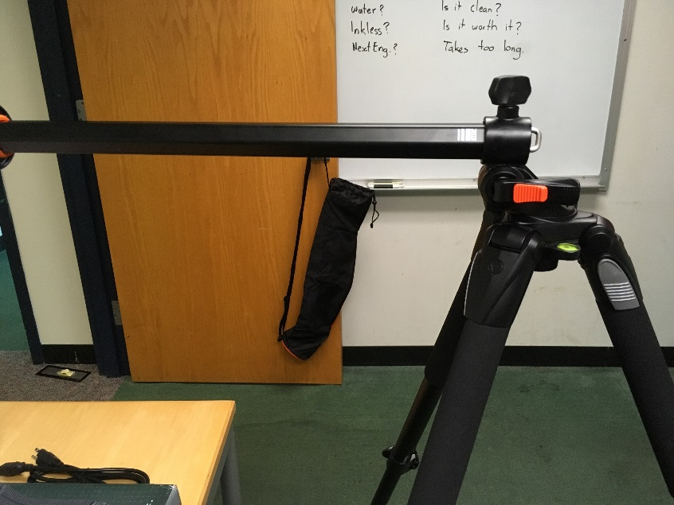

1. Push the Swivel Stop-n-Lock until it clicks back into place. The central column should now be locked in the 90 degree position shown above
2. Loosen Knob B and align the arrow with 0. Then tighten Knob B

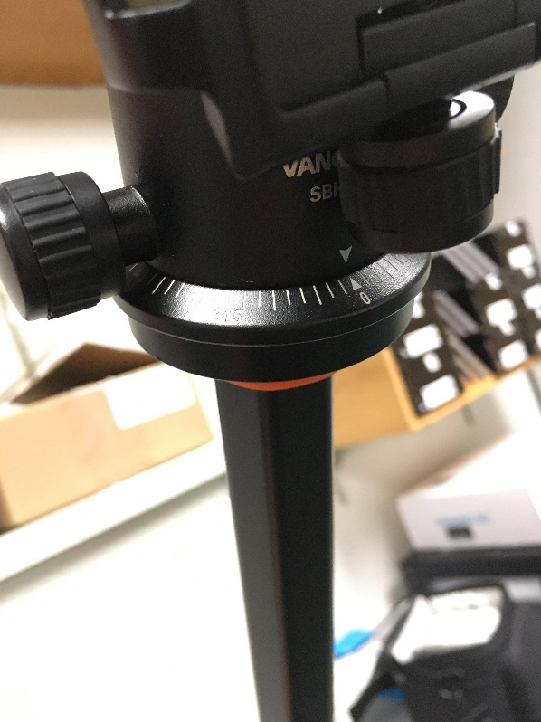

1. Screw the Quick Shoe into the bottom of the camera

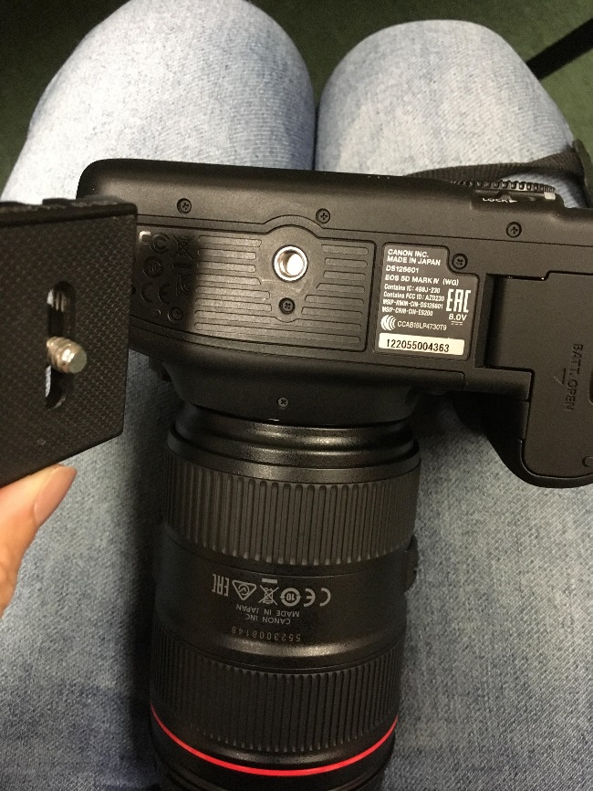

1. Loosen Knob F and slide the Quick Shoe (located on the bottom of the camera) into place on the tripod. Then tighten Knob F
2. Loosen Knob C and rotate the ball on the tripod head until the camera lens is parallel to the ground. Use the green level to ensure the camera is parallel. Then tighten Knob C

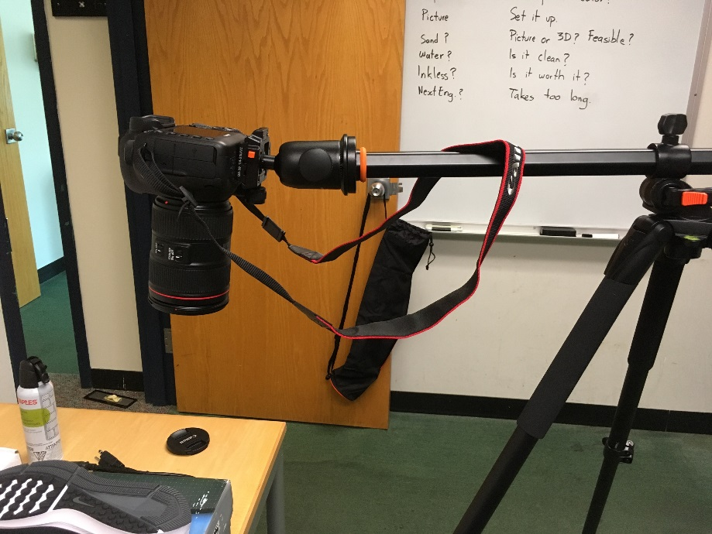

1. Position the tripod legs so that the camera is directly above the shoe
2. To adjust the camera lens, move the switch on the camera from “Lock” and rotate the lens to the suitable zoom setting